Faiza Abdullah

Lab 05 on MSLE Skillable Platform

ITAI 2376 Deep Learning in Artificial Intelligence

Professor: [Patricia Mcmanus](https://eagleonline.hccs.edu/courses/282423/users/264039)

**REFLECTIVE JOURNAL: EXPLORE GENERATIVE AI IN AZURE AI FOUNDRY PORTAL**

**PROOF OF COMPLETION:**

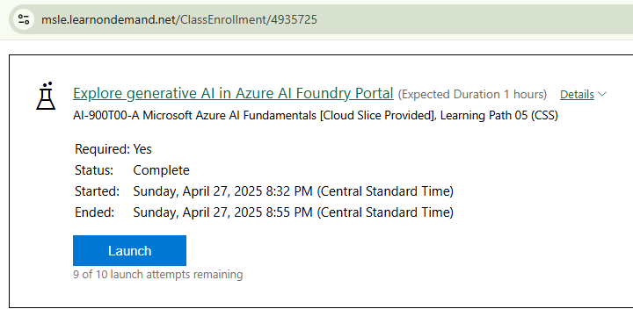

**INTRODUCTION**

This lab explored generative AI capabilities within the Azure AI Foundry portal, focusing on creating content with AI. The lab provided an introduction to how users can interact with generative AI, particularly through chat applications.

**LAB OBJECTIVES AND PROCESS**

The objectives included using the Azure AI Foundry portal to experiment with generative AI. The process involved accessing the Azure AI Foundry portal and utilizing the playground to interact with a generative AI model.

**WHAT I DID**

* After accessing the Azure AI Foundry Portal on the Microsoft Learn on Demand platform, I selected Chat playground.

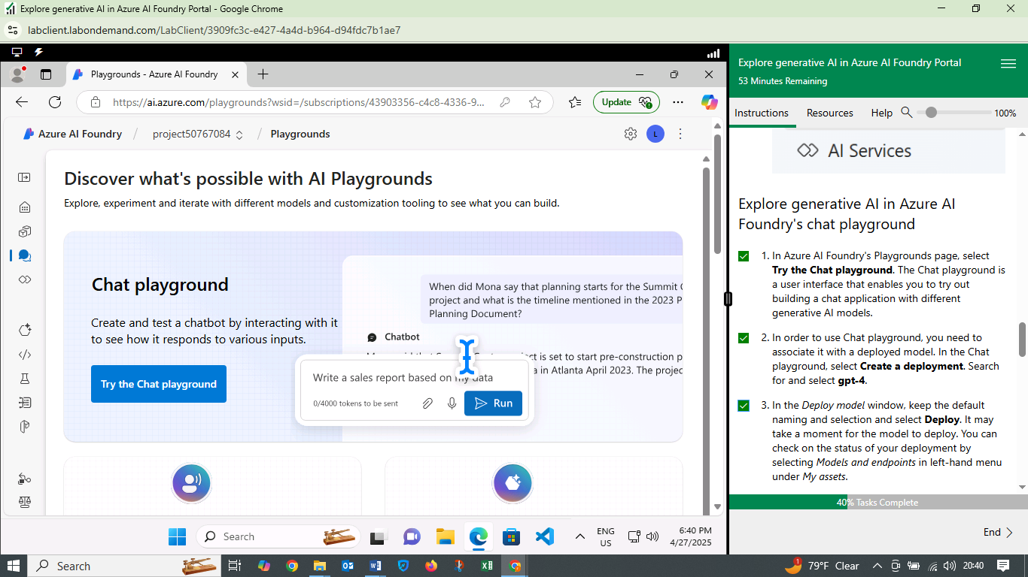

* Deployed the gpt-4 model within the Chat playground.

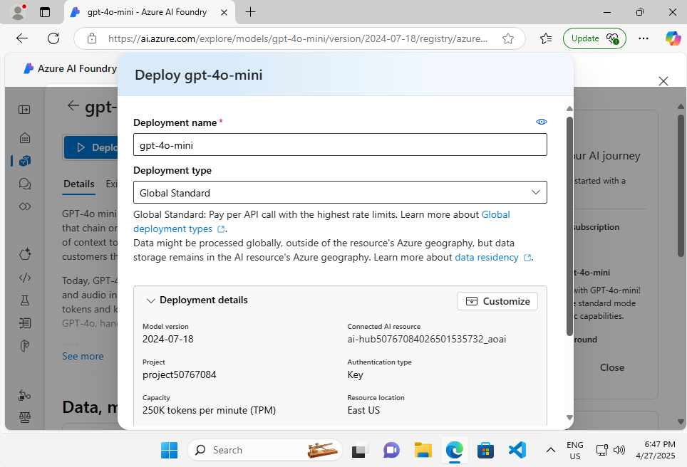

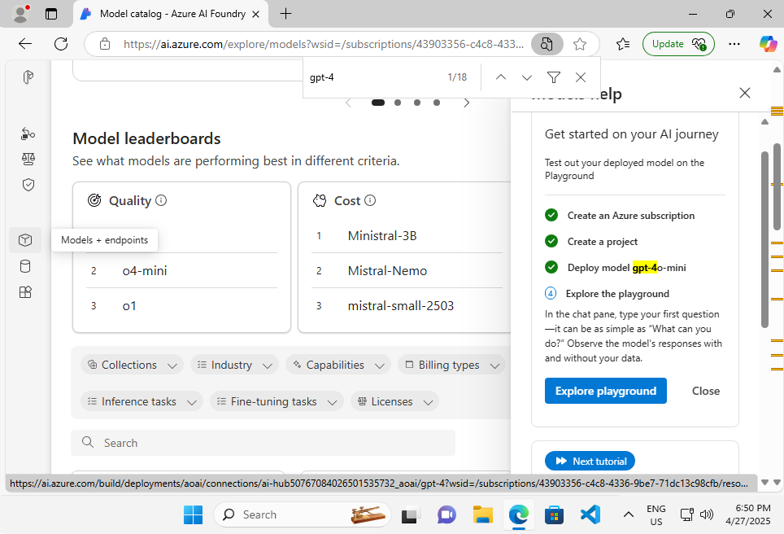

* Interacted with the Chat Model to engage in a series of prompts and responses, exploring the model's ability to generate human-like text. The interactions involved asking questions and refining prompts to guide the model's output. For example, I asked the model “Where's a good location in Paris to stay?” and then refined the prompt to get dining options and top sights.

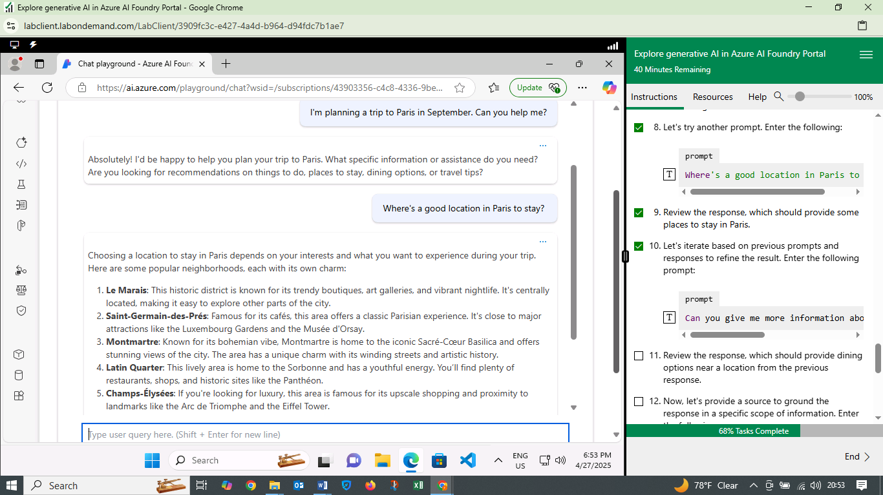

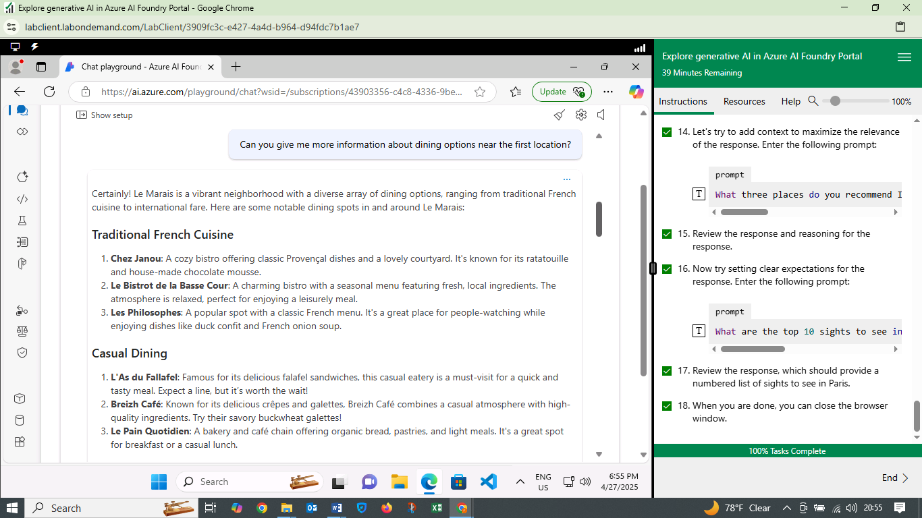

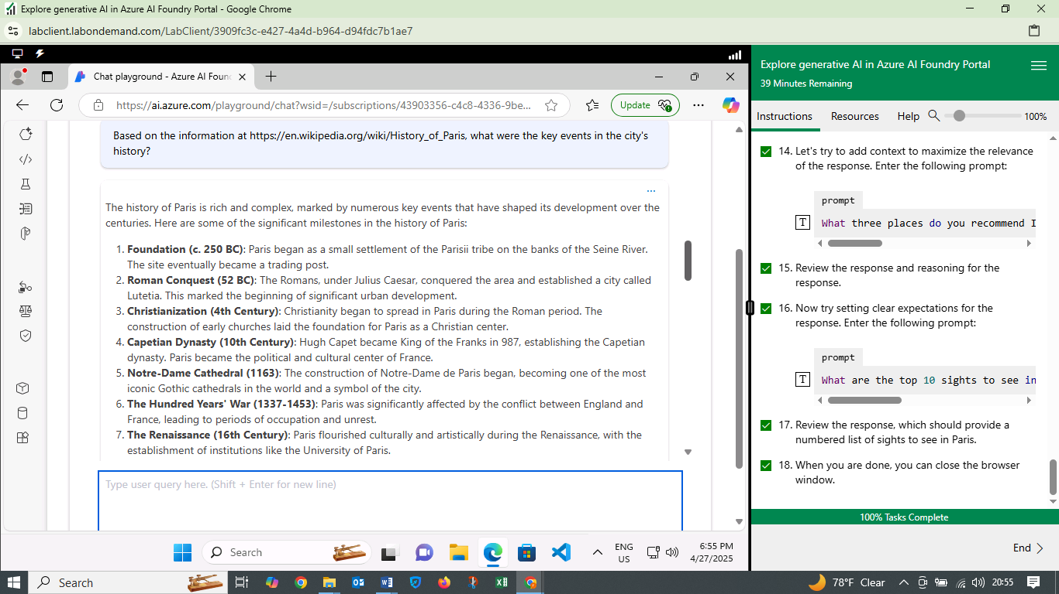

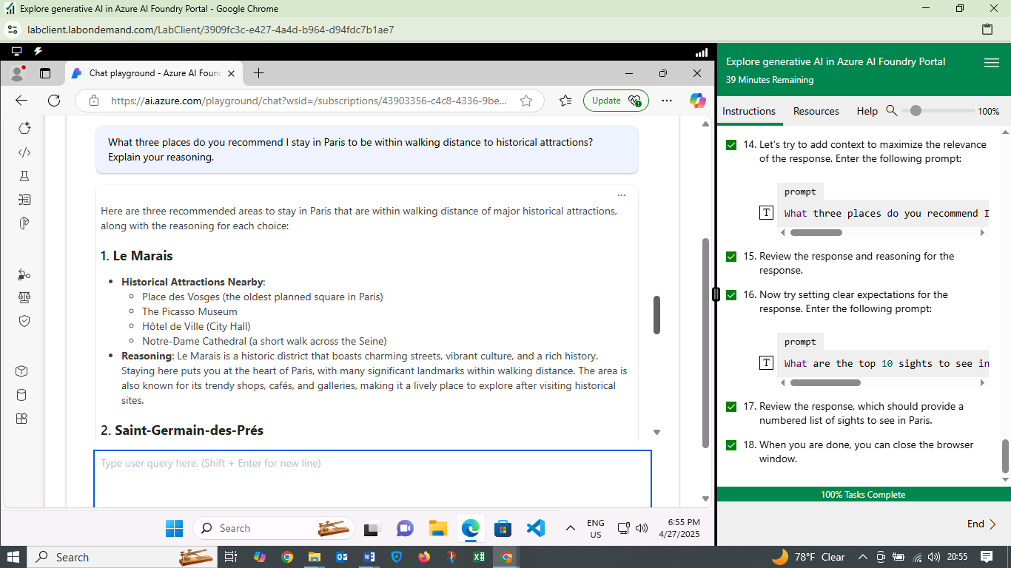

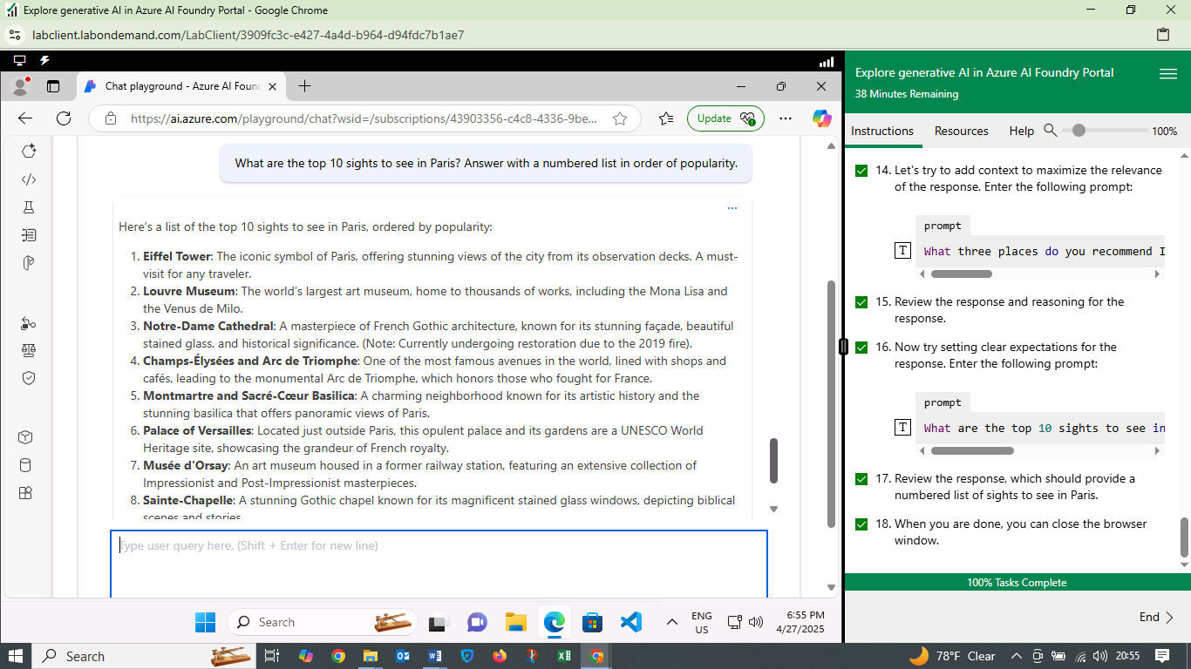

**WHAT I LEARNED**

* Generative AI Capabilities: I gained an understanding of how generative AI can be used to create content and engage in interactive conversations.
* Azure AI Foundry: The lab provided hands-on experience with the Azure AI Foundry portal and its tools for exploring AI models.
* Chat Applications: I learned how generative AI models can be used to build chat applications and create interactive user experiences.
* Prompt Engineering: The lab highlighted the importance of prompt engineering in guiding the output of generative AI models

**CHALLENGES FACED**

* Model Deployment: Deploying the gpt-4 model required navigating the Azure AI Foundry interface and understanding the deployment process.
* Prompt Refinement: Crafting effective prompts to elicit the desired responses from the model required some experimentation.

**INSIGHTS GAINED**

* Versatility of Generative AI: Generative AI has a wide range of potential applications, from creating content to powering conversational interfaces.
* Iterative Interaction: Interacting with generative AI models is an iterative process that involves refining prompts and responses to achieve the desired outcome.
* Potential for Automation: Generative AI has the potential to automate tasks such as content creation and customer service.

**CONCLUSION**

During the lab navigated the Azure AI Foundry portal, deployed a model, and interacted with it to generate text. The insights I gained about the capabilities, versatility, and potential applications of generative AI will be valuable in my future work with Azure AI technologies.